To-Do List Application Design

Erin Whitmore
Software Engineering, University of Minnesota Crookston
SE 2300: Software Construction
Dr. Silvia Preston
February 3, 2026

To-Do List Application Design
This document serves to help design the To-Do List application being coded in Python. It includes the problem statement and how the app will handle various errors and validate user info. It identifies the main methods of the class and outlines the pseudocode that will serve as the blueprint for the code. Finally, a flowchart has been created to help visualize the flow of data.
Problem Statement
The To-Do List Application will be a simple yet effective user-friendly tool that will allow anyone to quickly and easily list and organize a variety of tasks, whether those tasks are chore-related tasks or if they’re tasks used to keep track of school assignments. Users will be able to add tasks, list all tasks, update a specific task, and delete tasks. A variety of measures will be taken to ensure that user input is valid and the data is persistent.
Error Handling: Exceptions will be raised when a user enters a non-numeric input when the program expects a number, such as when asking which task the user would like to delete (based on the task number). The program will also appropriately handle if a user enters a negative index, a task number that doesn’t exist, or an empty string.
Data Validation: The program will ensure that the task description cannot be an empty string. The program will also ensure that at least one task has been added to the list before calling the routine that lists all tasks.
User Interface: The application will run on a command-line interface. It will feature numbered menu options for the user to choose from, clear prompts, consistent feedback messages, and task numbers starting from 1.
Data Persistence: The task data will be stored and retrieved using a simple text file (e.g., todotasks.txt). When loading tasks from the file, they will be appended to a list so they may be manipulated as the user pleases. When the user is done editing tasks, they will be stored back into the text file.
Design the System
The construction of the To-Do List app will consist of 6 primary methods:
- The loadFile() method will handle loading saved data from the selected text file and will append each task item (if any) to the list of tasks.
- The saveFile() method will save all task data into the selected text file upon exiting the program.
- The addTask() method will handle adding valid task data to the list of tasks.
- The updateTask() method will handle updating an existing task with valid task data.
- The deleteTask() method will delete a valid task option from the list as long as there is at least one item in the list.
- The listTasks() method will list all task items as long as there is at least one item in the list.
In addition to these class methods, a main() method will handle the functionality of the main menu and getting user input. The tasks list will be used to store existing task information. Upon running the application, task items will be read from a file and appended to the task list, and task items will be written to the file upon exiting the program. A class diagram is shown below to demonstrate these implementations.
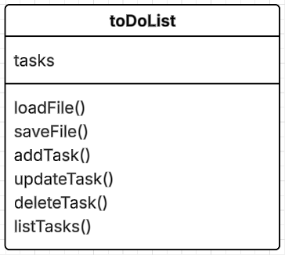
Class Diagram 1
Write the Pseudocode
When called, this routine (loadFile()) loads data from the text file and appends each line to the list in the application.
Open file for reading
For each line in the file
If there is a non-empty line
Append the line to the built-in application list
Upon exiting the application, this routine (saveFile()) will save all task data in the list into the text file.
Open file for writing
For each index (task item) in the list
Write the index (task item) to the file. Add a new line
Save and close the file
Main method for the program (main()). Greets the user, presents a menu list of options to choose from, and gathers/stores user input. It also loads task data from the text file if it has data to load, and saves data to the text file upon exiting the application. Responsible for running all the functions in the class.
Call loadFile() task
If file not found
Print error message saying file not found, starting with an empty list instead
Else
loadFile() appends task data from the text file to the list
Greet user. While user choice is not equal to 5
Display menu
Get user input
If input is invalid
Display error message. Ask user to choose a valid input
Else
If users’ choice is equal to 1, call routine to add task to the list.
If users’ choice is equal to 2, call routine to update a task in the list.
If users’ choice is equal to 3, call routine to delete a task from the list.
If users’ choice is equal to 4, call routing to list all tasks in the list.
If users’ choice is equal to 5, save list data to the file using saveFile() and quit the program.
This routine (addTask()) adds a task to the list of tasks. The routine will check to ensure that the input is valid before adding the task to the list, such as ensuring a non-empty string. If the input is invalid, the routine will output an error message. A confirmation message shall be printed once an item has been added.
Ask user to enter desired task
If user enters a valid task (non-empty string)
Add task to list of tasks
Output that task has successfully been added
Else, output that task cannot be empty. Exit to main menu
This routine (updateTask()) updates a list item based on the numeric input from the user corresponding to the list number item. Task items will be listed so the user can select which one they want to update. The routine will ensure that the input is valid before updating the task, such as ensuring the input is not an empty string. If invalid, an error message shall be displayed. The routine will not return anything.
Call routine to list all tasks.
If no tasks are in the list
Output that no items are in the list. Exit routine
Else
Ask user to enter task number to update
If user enters a valid task number
Select correct task number
If user input is valid
Update task slot with updated information
Output that the task has been successfully updated
Else
Output that the user must select a valid task number
This routine (deleteTask()) delete a task from the list. Task items will be listed so the user can select which one to delete. The routine will check to ensure input is valid from the user, such as proper task number and that there is at least one item in the list. If the input is invalid, the routine will output an error message. The routine will not return anything once a task has been updated.
Call routine to list all tasks.
If no tasks are in the list
Output that no items are in the list. Exit routine
Else
Ask user to enter task number to delete
If user enters a valid task number
Remove task from the list
Output that the task has been successfully deleted
This routine (listTasks()) will list all task items. The routine will check to ensure that at least one task has been added to the list before outputting the task items, otherwise it will display that there are no tasks to be listed. If successful, the routine returns a list of tasks.
If the list is not empty
Output each task item with corresponding task number, line-by-line
Else
Output that no data has been added to the list
Create a Flowchart
The flowchart represents the flow of possible actions the user may take. Upon starting the application, the user is taken to the main menu. There, they may select to add a task item, update a task item, delete a task item, list all task items, or exit the program. All options (except exit) route back to the main menu so the user can freely select options until they are finished.
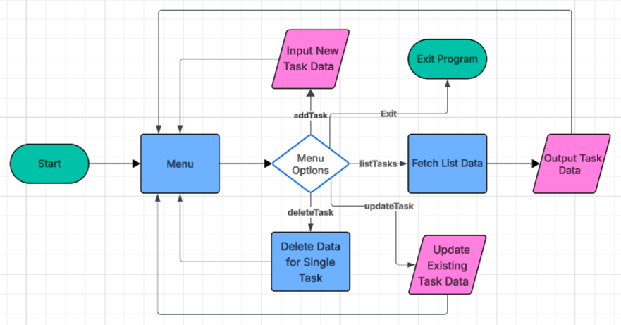
Flowchart 1

